COMPARison Of three types OF NEURAL SPEED ESTIMATORS
FOR THE INDUCTION MOTOR DRIVE

Jaroslava Žilková, Jaroslav Timko, Peter Girovský
Department of Electrical Drives and Mechatronics, Technical University of Košice,
Letná 9, 042 00 Košice, Slovak Republic
E-mail:jaroslava.zilkova@tuke.sk , jaroslav.timko@tuke.sk , peter.girovský@tuke.sk

Abstract: Presented paper describes design and the comparison of different structures of artificial neural networks (ANN) and their applying to dynamical system modelling. Shaft sensorless control of induction motor drives requires knowledge of the instantaneous value of the rotor speed. This paper considers the problem of speed estimation, based on neural modelling approach, in the shaft sensorless field oriented control structure with the induction motor (IM). Various internal structures of neural speed estimators are simulated and their performances are compared. Structures of the ANN estimators are based on measurable motor variables: components of stator current and voltage.

Key words: Induction motor (IM), rotor speed estimation, artificial neural network (ANN), feed forward neural network (FFNN), cascade feedforward neural network (CFNN), Elman neural network, field oriented control (FOC) of IM, sensorless speed control.

1. Introduction.
DC motors have been used widely in industrial applications and in many other applications where variable speed operation are needed. In their early days, dc motors had the advantage of precise speed control when utilized for the purpose of accurate driving. However, dc motors have the disadvantages of brush erosion, maintenance requirements, environmental effects, complex structures and power limits. On the other hand, induction motors are robust, small in size, low in cost, almost maintenance-free.
Hasse and Blaschke developed a field oriented control theory to simplify the structure of IM speed control used to drive like DC motor. In recent years, the field oriented control theory has become more feasible due to progress in the development of electronics techniques and high-speed microprocessors. Non-linear control problems can often be solved if full state information is available, in the IM case the rotor states are immeasurable and often the angular speed of the rotor is too costly to be monitored.
In most applications, speed sensors are necessary in the speed control loop. On the other hand, there exist applications where lower performance is required, cost reduction and high reliability are necessary, or hostile environment does not allow to use speed sensors. In these fields, speed sensorless IM control can be usefully applied.
Many different solutions for the estimation of states variables or model parameters have been proposed at the present time.

Well known are following types of estimators:
- estimators utilizing the motor construction properties
- estimators based on the drive dynamic model
- estimators based on artificial intelligence

Sensorless controllers, which depend on adaptive control and observer theory [1], on optimal observer design by applying Kalman Filter theory [2], on sliding mode control [3], on artificial intelligence [4, 5] have been proposed.
At present, provided requirements on the dynamic precision are not too strict, virtual or soft sensors are alternatively successfully utilized.

Estimators based on artificial intelligence can be divided into some groups:
- systems based on the fuzzy logic
- systems based on neural networks
- systems based on neural-fuzzy systems
- systems based on evolutionary algorithms (genetic algorithms)

Our works was divided into some steps:
- choosing proper values of the motor as neural networks inputs, corresponding to the output, i.e. speed,
- designing an induction motor system in order to obtain input/output training data,
- modelling neural networks using designated input/output data,
- testing the neural estimators
- comparing the neural estimators

signals for the induction motor speed reconstruction. The suggested estimators were trained according to selected training patterns from the field oriented controlled IM.
The block diagram of the control scheme is presented in figure 1.

- The neural estimators design.
The neural modelling can perform estimation of the induction motor angular speed or other nonmeasurable variables.
Today field oriented controlled drives with different solutions and performance, are an industrial reality. With the field-oriented techniques, the decoupling of flux and torque control commands of the IM is guaranteed, and the induction motor can be controlled linearly like a separated excited DC. motor. DC motor like performance can be obtained in holding a fixed and orthogonal orientation between the field and armature fields in an IM by orientating the stator current with respect to the rotor flux so as to attain independently controlled flux and torque. Using the field oriented control principle the stator current component i_{1d} is aligned in the direction of the rotor flux vector and the stator current component i_{1q} is aligned in the direction perpendicular to it. The rotor flux orientation in a squirrel-cage rotor induction motor cannot be directly measured, but it can be obtained from terminal measurements.
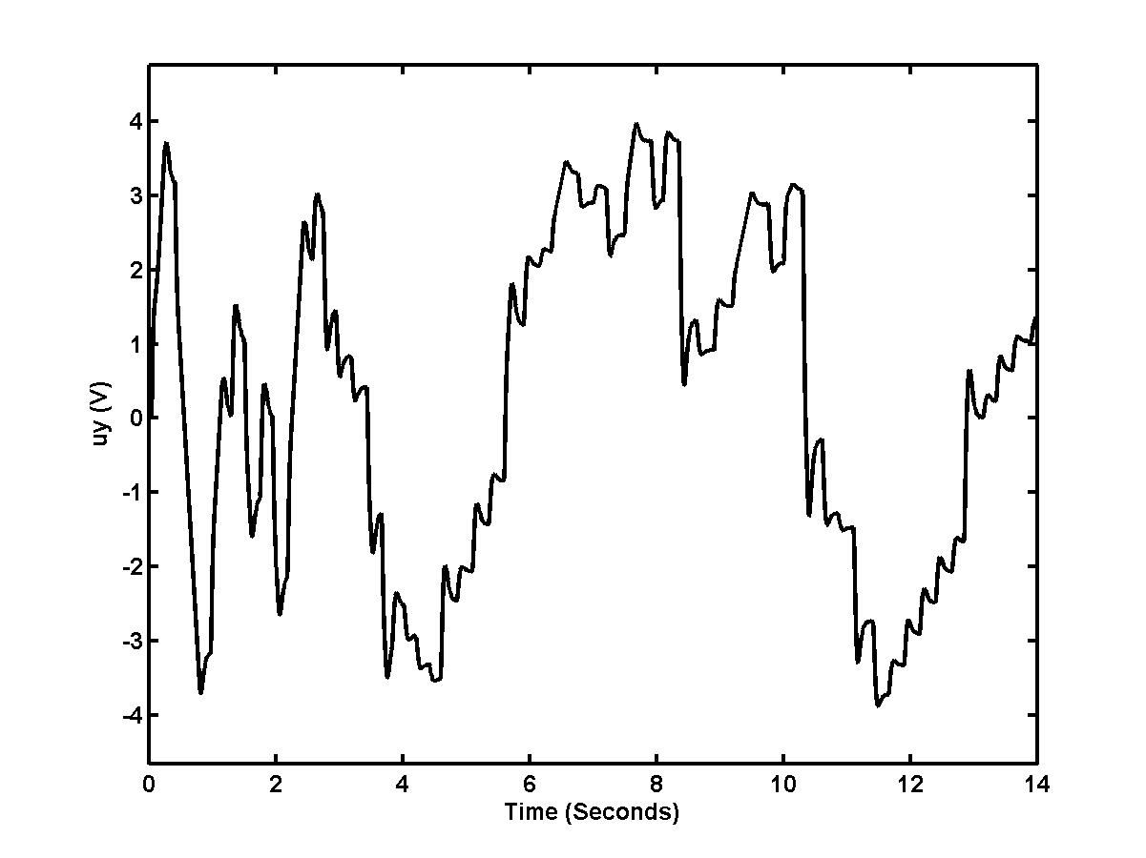
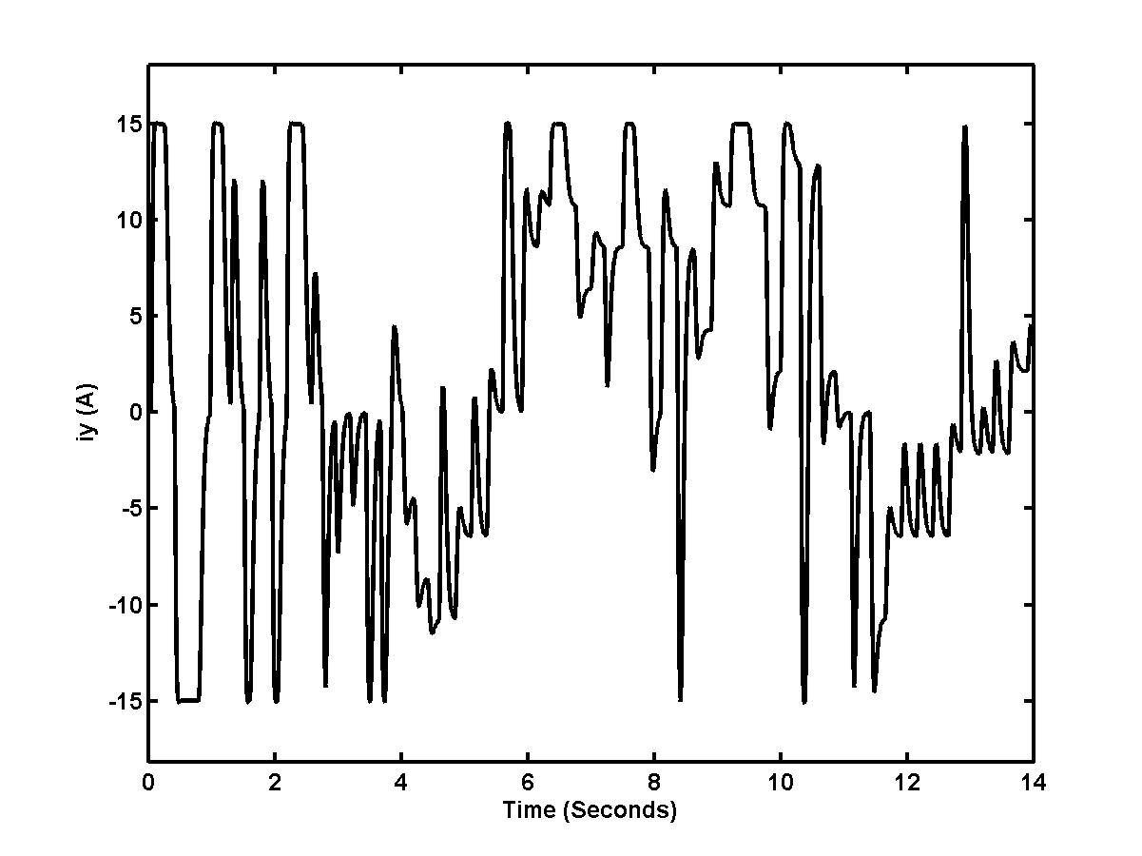
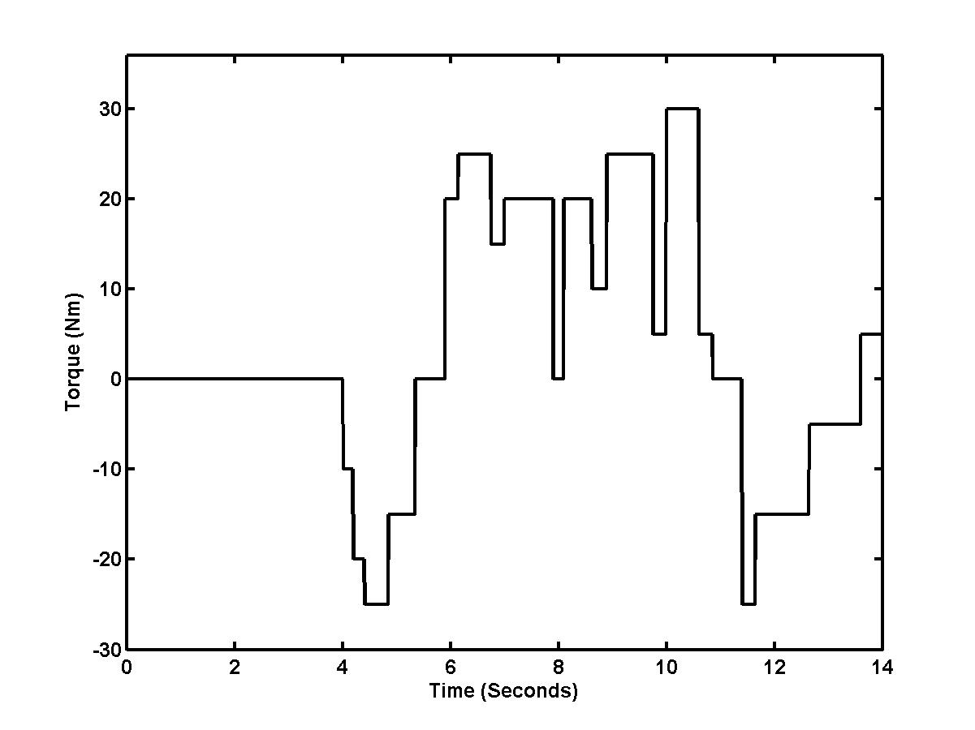
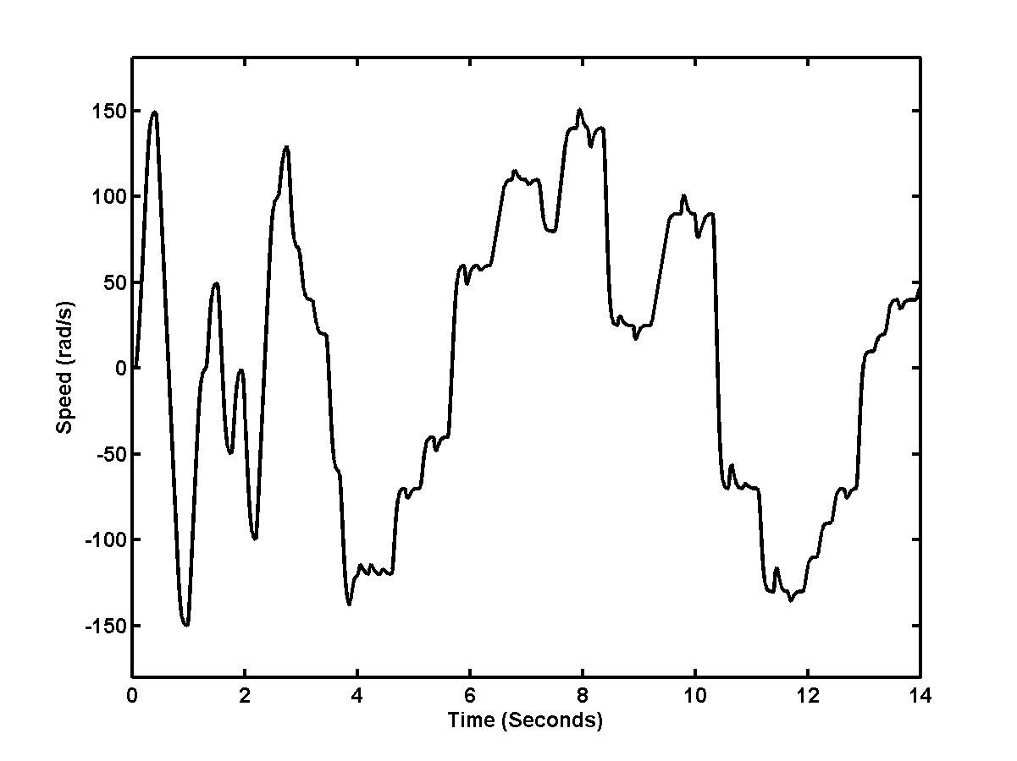
After using transformation of coordinates d, q to rotating system x, y is considered, that the electric torque is proportional to the i_{1y} component and the relation between the rotor flux and i_{1x} component is given by a first order linear transfer function with a time constant T₂= L₂/R₂. From this fact and for considered constant – flux value control, stator current and voltage components were chosen as input
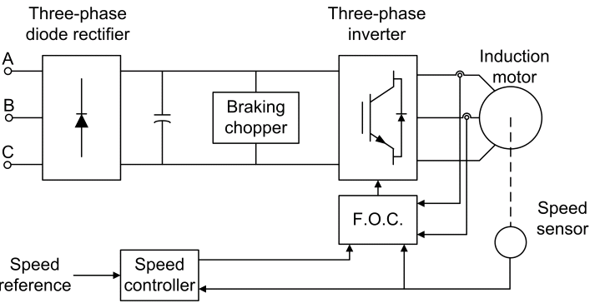

Fig. 1. Basic field oriented control scheme.

For training purpose used were two types of training inputs:
- for networks with four inputs the inputs are: u_{1y(k)}, u_{1y(k-1)}, i_{1y(k)}, i_{1y(k-1)}
- for networks with six inputs the inputs are: u_{1y(k)}, u_{1y(k-1)}, i_{1y(k)}, i_{1y(k-1)}, ω_{(k-1)}, ω_{(k-2)}.

The four inputs estimators approximated rotor speed by using following function dependence:

$ω_{\left(k\right)}=f\left[u_{y\left(k\right)},u_{y\left(k−1\right)},i_{y\left(k\right)},i_{y\left(k−1\right)},\underline{w}\right]$ (1)

and six inputs networks approximated rotor speed by using following relation:

$\begin{matrix}ω_{\left(k\right)}=f[u_{y\left(k\right)},u_{y\left(k−1\right)},i_{y\left(k\right)},i_{y\left(k−1\right)…} \\ …ω_{\left(k−1\right)},ω_{\left(k−2\right)},\underline{w}]\end{matrix}$ (2)

Shown in Fig. 2 are examples of selected training patterns: y- supply voltage and stator current components, load torque changes and the motor angular speed.

Fig. 2. Example of training patterns (u_{1y}, i_{1y}, T_{L,}, ω).

For angular speed estimation of the IM chosen were three types of neural network structures:
- multilayer feedforward ANN
- cascade feedforward ANN
- Elman recurrent ANN

Shown in Fig. 3-5 are examples of selected types of the ANNs.
For angular speed estimation of the IM chosen were types of neural networks with one and two hidden layers. Levenberg-Marquardt variation of the backpropagation learning algorithm was used to off-line training the neural estimators. Desired accuracy of all learning processes was 10e⁻¹⁰ during maximum of 200 epochs.

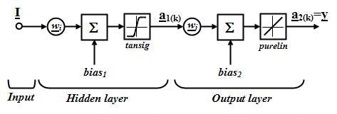

Fig. 3. A multilayer feedforward neural network.

Outputs from 1st and 2nd layer of the FFNN are by relations:

$\begin{aligned}{\underline{a}}_{1\left(k\right)}=\text{tan}\text{sig}\left(\underline{I}{\underline{w}}_{i}+{\text{bias}}_{1}\right) \\ \\ {\underline{a}}_{2\left(k\right)}=\text{purelin}\left({\underline{a}}_{1\left(k\right)}{\underline{w}}_{j}+{\text{bias}}_{2}\right)\end{aligned}$ (3)

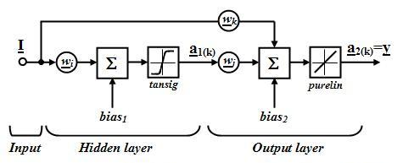

Fig. 4. A cascade feedforward neural network.

Outputs from 1st and 2nd layer of the CFNN are by relations:

$\begin{aligned}{\underline{a}}_{1\left(k\right)}=\text{tan}\text{sig}\left(\underline{I}{\underline{w}}_{i}+{\text{bias}}_{1}\right) \\ \\ {\underline{a}}_{2\left(k\right)}=\text{purelin}\left(\underline{I}{\underline{w}}_{k}+{\underline{a}}_{1\left(k\right)}{\underline{w}}_{j}+{\text{bias}}_{2}\right)\end{aligned}$ (4)

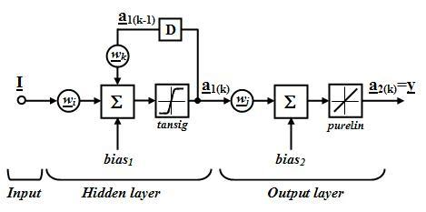

Fig. 5. An Elman neural network.

Outputs from 1st and 2nd layer of the Elman NN are by relations:

$\begin{aligned}{\underline{a}}_{1\left(k\right)}=\text{tan}\text{sig}\left(\underline{I}{\underline{w}}_{i}+{\underline{a}}_{1\left(k−1\right)}{\underline{w}}_{k}+{\text{bias}}_{1}\right) \\ \\ {\underline{a}}_{2\left(k\right)}=\text{purelin}\left({\underline{a}}_{1\left(k\right)}{\underline{w}}_{j}+{\text{bias}}_{2}\right)\end{aligned}$ (5)

In Fig. 6 are shown training processes of individual neural network types for the same 4-6-1 networks configuration.
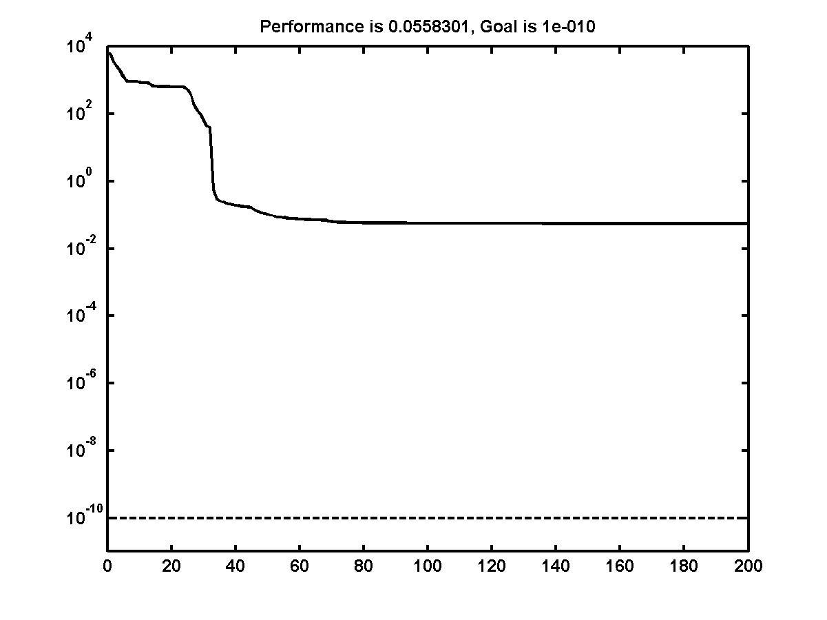
a)
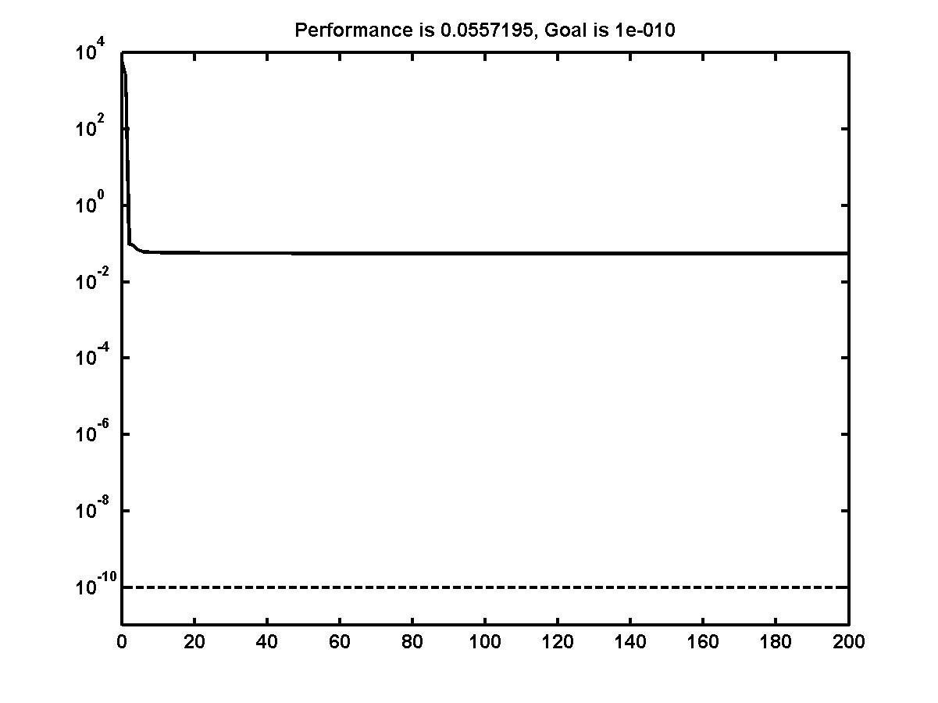
b)
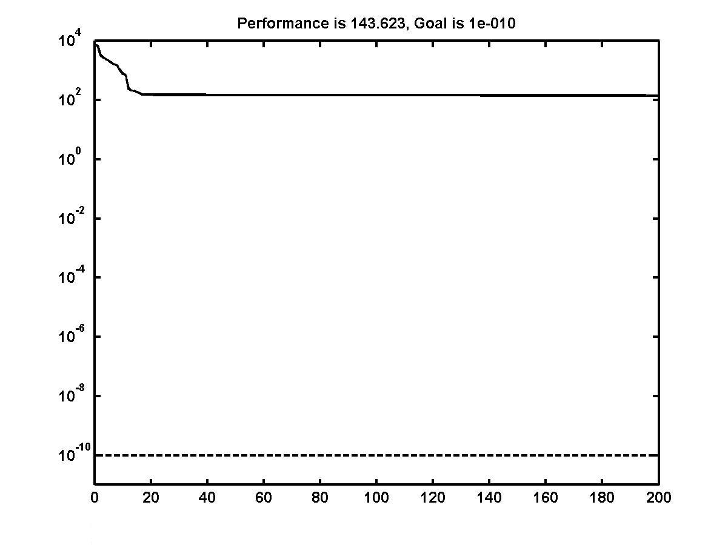
c)

Fig. 6. Courses of 4-6-1 neural estimators learning: a, FFNN b, CFNN c, Elman network.

3. Simulation results.
In this section we will study the speed regulation performance of the field-oriented control IM versus reference and load torque variations by means of simulation examples.

The IM used in this case study is 3kW motor having the following parameters:

U = 220 V/50 Hz, I_{N} = 6.9A, n_{N} = 1420 rpm,
R₁ = 1.81 Ω, R₂ = 1.91 Ω, L_{1σ} = L_{2σ} = 0.00885 H,
L_{h} = 0.184H, p_{p} = 2, M_{N} = 20.17 Nm, J = 0.1 kgm²

After training the estimators, with different representations of the input, and different numbers of units in the input and hidden layers we compared the networks to each other. We compared the networks by simulating them on the same testing data, but different from the training set.

In the following figures, chosen results of IM speed reconstruction are presented. In all figures are demonstrated transients of real (simulated from the IM model) of motor speed together with the angular speed estimated by one of the types neural networks.
The system starts with zero load torque and at time t= 6s the load torque steps from T_{L}=0 Nm to T_{L}= 20Nm. All the other changes of the speed courses are caused by reference speed values changes.
In the fig. 7 are demonstrated transient of rotor speed by all three types of neural networks with relatively simple structure 4-6-1.
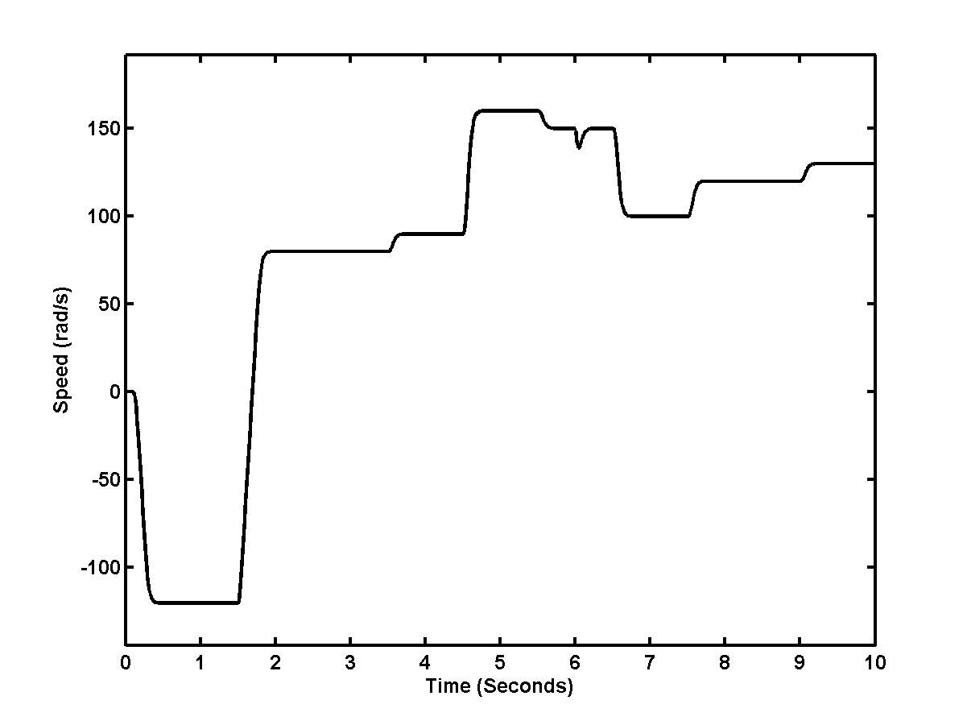
a)

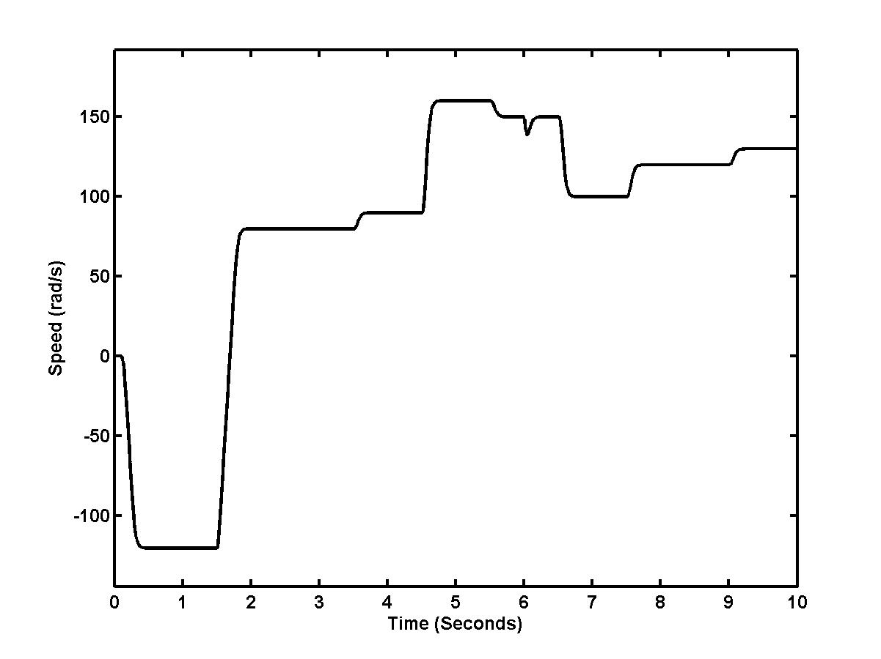
b)

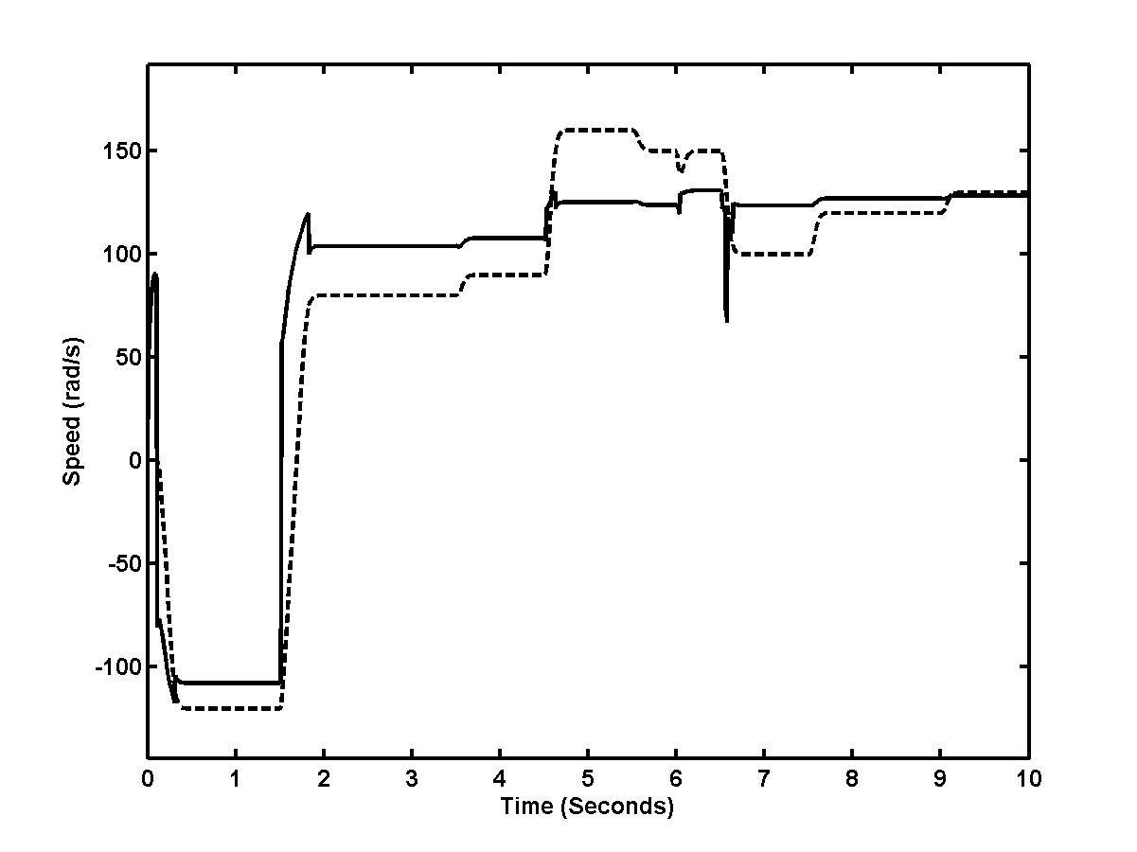
c)

Fig. 7. Transients of the rotor speeds: real speed and speeds of 4-6-1 neural estimators:
a, FFNN b, CFNN c, Elman NN.
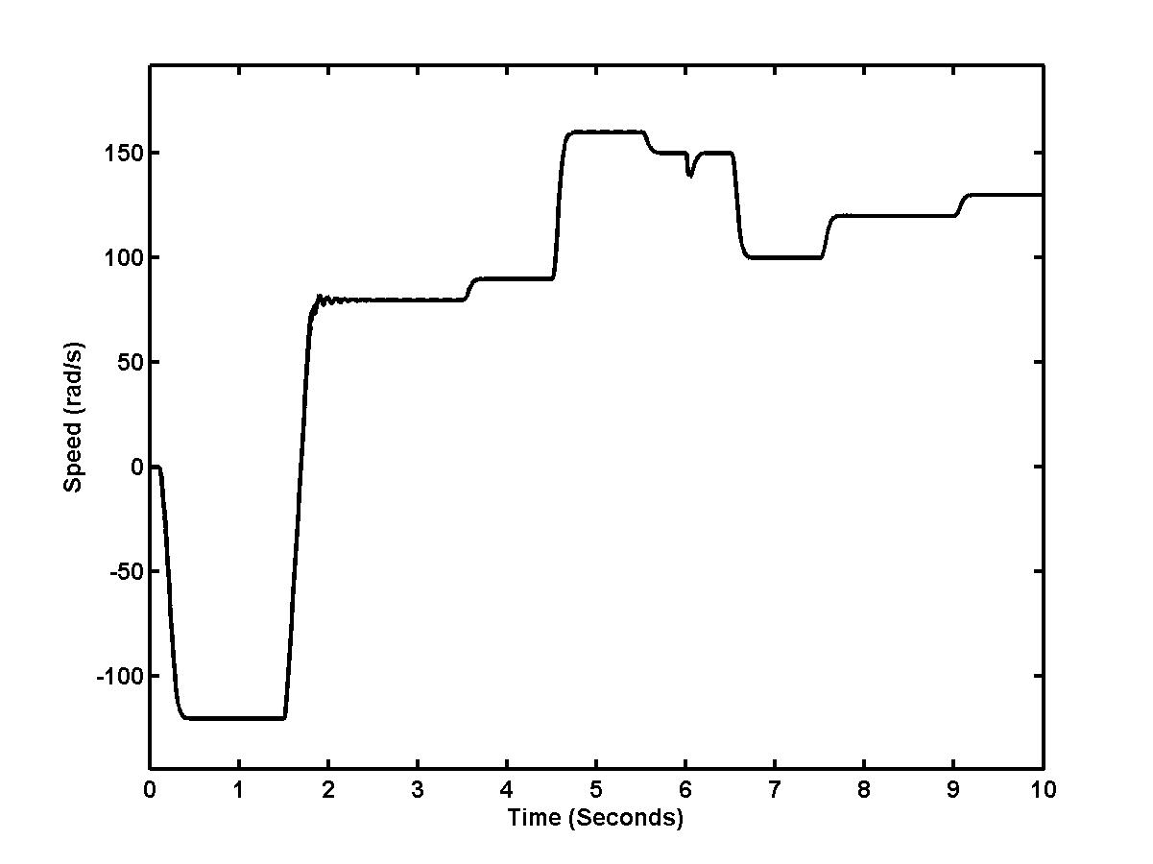
a)

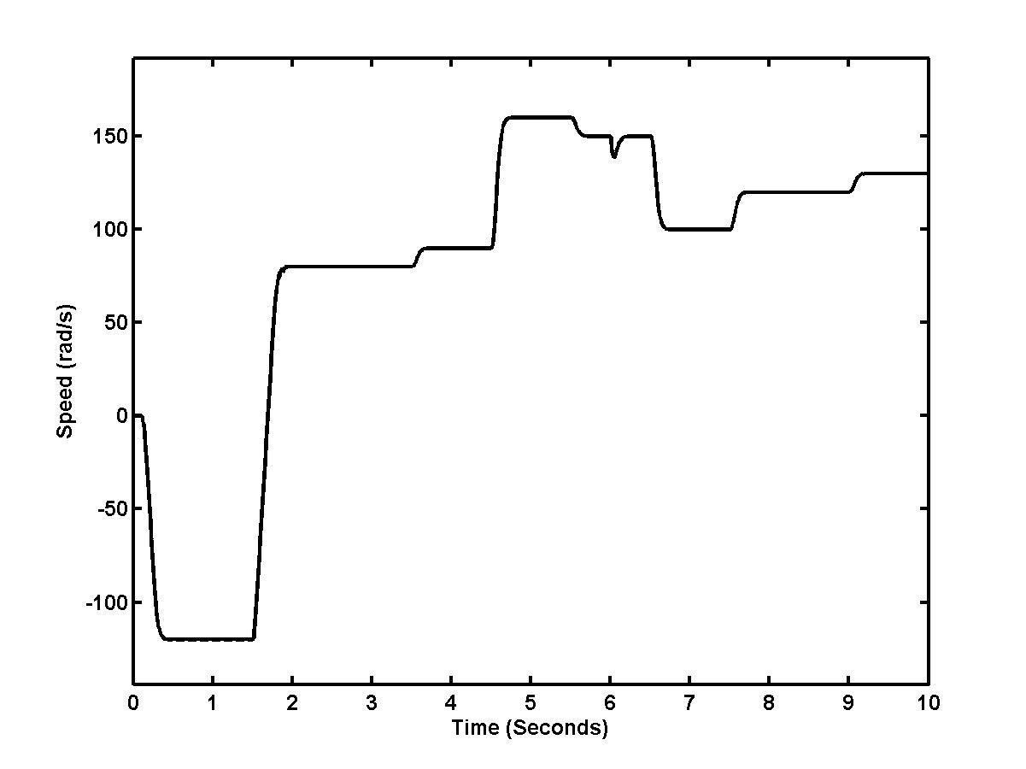
b)

Fig. 8. Transients of the rotor speeds: real speed and speeds of 6-6-1 neural estimators:
a, FFNN b, CFNN.

In fig. 8 demonstrated are transient of rotor speed by only two types of networks with structure 6-6-1. The results of the estimator based on the Elman network were unsatisfactory.

In the fig. 9 demonstrated is transient of rotor speed by CFNN network with structure 6-8-12-1. The results of the estimator based on the FFnn and Elman networks were unsatisfactory, too.

Figure 10 shows the desired rotor speed and the real rotor speed in the IM speed sensorless FOC. In the figures are demonstrated speed courses of control structure (Fig.1) with both neural estimators where were used: a, FFNN and b, CFNN with 4-6-1 configurations.
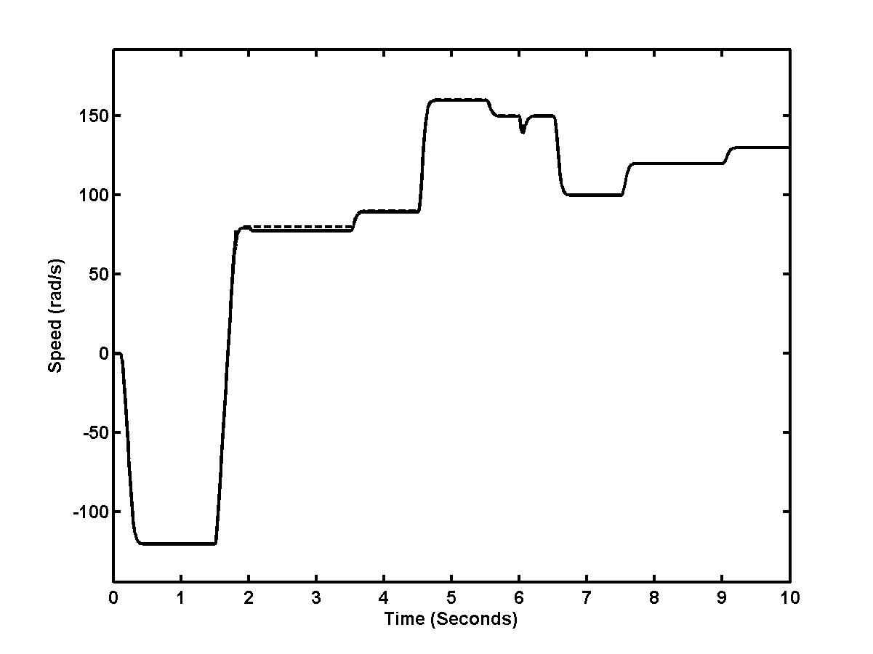

Fig. 9. Transient of the rotor speeds: real speed and speed of 6-8-12-1 CFNN neural estimator.

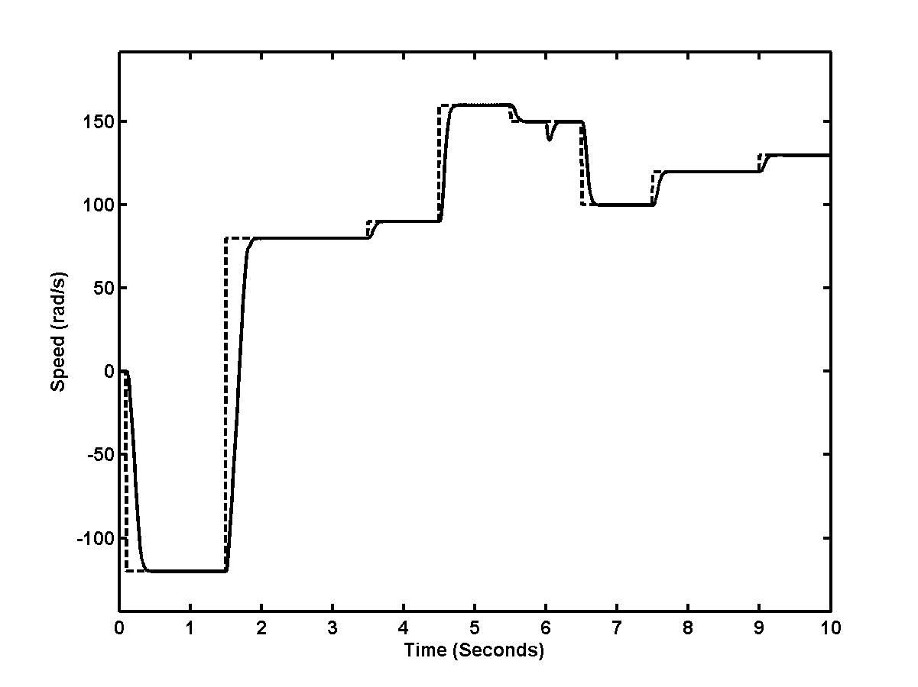
a)
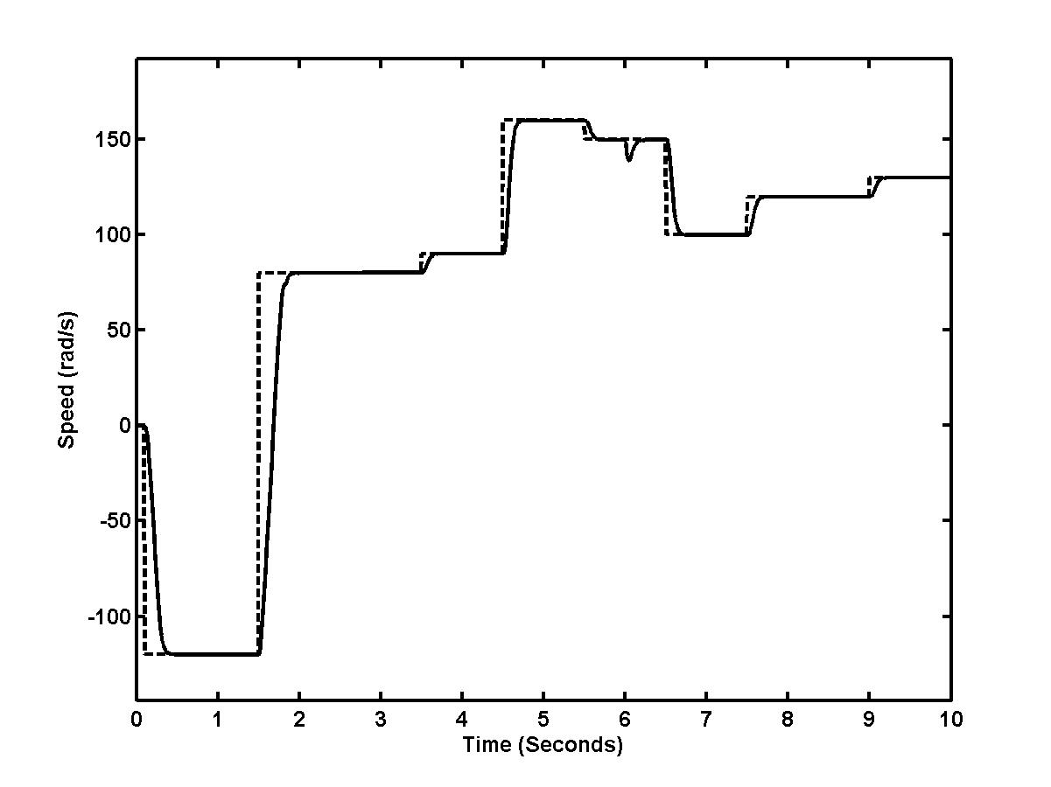
b)

Fig. 10. Desired and real speed in the IM sensorless FOC: a, FFNN b, CFNN estimator.

4. Conclusion.
The paper deals with the design of speed neural estimators for an induction motor shaft sensorless field oriented control based on different neural network structures. The design of neural speed estimators is based on sensor information pertaining to stator voltage and current of the induction motor. The paper presents comparison of three neural networks types: FFNN, CFNN and Elman neural networks with one or two hidden layers and with four or six inputs values. Levenberg-Marquardt variation of the backpropagation learning algorithm was used. All the networks are trained off-line in order to minimise the control performance. Training samples for an ANN controller were attained via simulation of an induction motor field oriented control in Matlab-Simulink environment.
The attained results show of feasibility of using the suggested IM angular speed neural estimators, but the effectiveness of the estimators is different.
Adequate accuracy of angular speed estimation was achieved by FFNN and CFNN. The best results were obtained by CFNN with one hidden layer. The larger number of delayed input values improves the speed estimation quality.

Aknowledgement
Authors gratefully acknowledge support of VEGA 1/2177/05 at this work.

References
- Vas, P.: Parameter estimation, condition monitoring and diagnosis of electrical machines. Oxford University Press, Oxford, 1993.
- Orlowska-Kowalska, T., Dyrcz, K. P.: Induction motor flux, speed and rotor time-constant estimation using extended Kalman filter. In Proceedings of the EDPE’03, International Conference, Slovakia, 2003, pp.491-496.
- Vittek, J.- Dodds, S. J.: Forced dynamics control of electric drives. ŽU, EDIS Žilina, 2003, Žilina.
- Vas, P.: Artificial-inteligence-based electrical machines and drives. Oxford University Press, 1999, Oxford.
- Jovankovič, J., Žalman, M.: Application of the virtual sensors based on the artificial neural networks, EDPE’03, International Conference, Slovakia, 2003, pp.486-490.
- Narenda, K.S.: Neural networks for control: Theory and practice. In: IEEE Transactions on Neural Networks, 1996.
- Demuth,H.- Beale,M.: Neural network toolbox. User Guide, The Mathworks Inc., USA, 1994.

