REGEN 1x15 kW - an industrial automation system for small scale hydrogenerators supplying insular or grid consumers

Radu BABĂU - VARSPEED Hydro, Timişoara; Ovidiu MUNTEAN; Sever SCRIDON - BEESPEED Automatizari, Timişoara; Alexandru HEDEŞ; Ion BOLDEA; Nicolae MUNTEAN - University “POLITEHNICA”, Timişoara; Ioan Grando - U.C.M. Reşita

Abstract: The paper presents a flexibile automation system, dedicated to small scale hydrogenerators supplying insular or grid consumers. REGEN uses variable speed operated (VSO) turbines, in order to match the power produced with the network needs. A short introduction to variable speed operated turbines behaviour is first presented. The REGEN structure is also introduced, in a couple of functional structures, as well as experimental data for a commercial 15 kW system.

Key words: Variable speed operated turbines, Asynchronous generators, Insular grid power source, Automation for small scale hydro-units.

- Introduction.
Today energy market liberalisation in Romania brings new oportunities for rehabilitation or building small scale hydro sites (5-2,000 kW). Low maintenance costs inherently demands autonomous functionality for these installations. Simple turbine equipment, with good efficiency over a large flow interval is desired as well. Complete local automation and plant remote control also requires an increased flexibility for the turbine + generator group. The REGEN industrial automation system has been developed to encompass all of these goals by means of variable speed.

2. Variable speed operation (VSO) turbine.
The idea of VSO of a turbine is to allow the turbine speed to change with hydraulic conditions in order to maximise the turbine efficiency. Fig. 1A shows the velocity vectors at the turbine blades at design flow. For a lower flow (Fig. 1B), the guide vanes are closed and the turbine blades are turned accordingly. At a variable speed Kaplan turbine with fixed blade angle (Fig. 1C), the speed is reduced in proportion with flow, so that the fluid velocity vectors match the design conditions.

A B C
Fig. 1. Fluid velocity vectors [6, 7]

The realistic behaviour of turbine operating at variable speed is shown in the hill charts which are normally determined from model tests. Today, double regulated Kaplan turbines are designed so that the efficiency does not vary a lot with the flow, for a fixed speed, as shown in Fig. 2A. The same turbine operating as propeller turbine, fixed blade angle, shows a very narrow area of high efficiency around the Q~n line. The typical efficiency curve of such a propeller turbine is shown in Fig. 2B. Operating at variable speed, the efficiency follows the Q~n line and so, we find a high efficiency over a wide operating range, without modifying the blade pitch angle.
Fig. 2. Idealised hill charts of A: Kaplan (left) and B: propeller turbine (right) [5].

The VSO causes higher losses in the electrical system due to the frequency converter as an extra component. Assuming the same turbine efficiency for a Kaplan and Propeller turbine at the design point, this leads to a reduced system efficiency. But the advantage of the system only occurs under conditions which are different from the design conditions. Especially a head variation leads to remarkable efficiency reduction also for a Kaplan turbine, as shown in Fig. 3. At VSO, the efficiency shows only very small variations with head.
Fig. 3. Effect of head variations and speed variations on turbine efficiency [9]

VSO does not only allow lower, but also higher speeds than rated. Consequently, the turbine can handle lower and higher flows as well. Making use of this option in a typical low head run off the river scheme one achieves the same amount of electric energy with a VSO propeller turbine as with a double regulated Kaplan turbine (for same design parameters).
Torque (-) and power (- -) vs. speed
Maximum power speed
In the hill chart, Fig. 4, the operating curve along the maximum efficiency, with VSO, is shown (A) in comparison with the vertical line, representing constant speed operation at constant head (B). Optimum operation along this line can be achieved by using the guide vane opening for flow control and the speed control in order to match the actual head. The theoretical maximum efficiency increase at partial load is also shown (C). Finally, the possibility of using higher speeds allows to handle higher flows. The operating range of the variable speed turbine is therefore increased (D).
It has been also shown also that Kaplan turbines [8, 9] and centrifugal pumps as turbines [5] behave in the same manner if driven with variable speed.

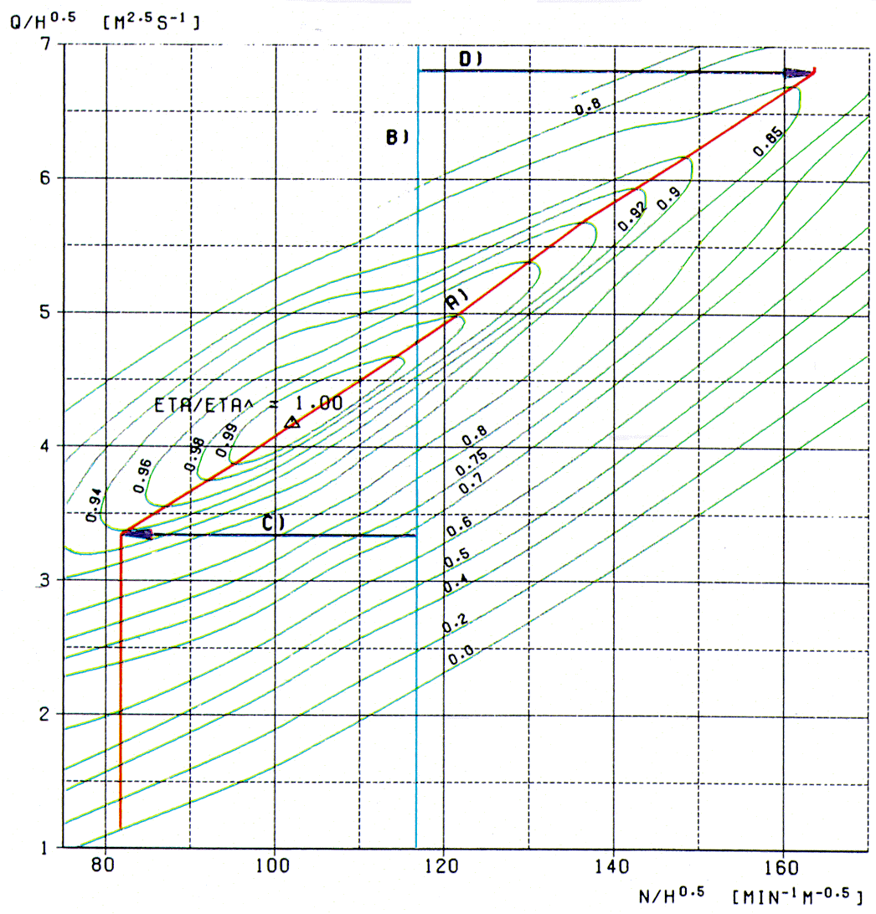

Fig. 4. Hill chart of the Kaplan turbine [8]

- REGEN functionality and basic principles.
REGEN equipment is designed to drive standard AC induction generators coupled with various small scale turbine types, used for supplying insular or grid consumers, 3~400 Vac +PE, 50 Hz.
Considering the torque and power characteristics of the turbine (Fig. 5), REGEN will drive the generator with variable speed, thus allowing the system to adapt always to the output power needed by the consumers.

Fig. 5. Turbine torque and power vs. speed

Using the frequency converter, the turbine will be run at the maximum efficiency speed, and not at the generator rated speed, thus maximising the overal economic results.
Depending on the application (see Fig. 6), various REGEN system configurations are possible.

1. Load type:

2. Energy demand:

3. Water
resource:

4. Speed
control
philosophy:

5. Product:
GRID
INSULAR
GRID + INSULAR
Maximum power
Required power
Maximum or required power
In excess
Limited
Proper speed for maximum power
Proper speed for required power
Proper speed to keep a constant level in the dam or intake
Proper speed for required power, but no more than proper speed to keep a constant dam level
REGEN - compact automation system for small scale
hydro-generators supplying insular or grid consumers
Fig. 6. REGEN application notes.

In either configuration, REGEN will manage the water resource in the above dam, as follows:
- if there is water in excess, the purpose of the automation is to maximize the power level pumped in the grid;
- if the available water source is weak (dry season), it will produce so much power (by reducing the turbine speed) that the water level in the dam will be kept at a programmable level.

3.1. REGEN for grid connection.
In this configuration (see Fig. 7), REGEN uses the benefits of standard 4Q frequency converters based on modern IGBT’s, available today also for PM synchronous generators. Based on this hardware platform, multiple application and automation phylosophies [1,2,3,4] are at hand. As relevant features for the small scale hydro application, we point out:
- motor - generator functionality, with smooth turbine START / STOP (Fig. 8,-9);
- availability up to 2 MW units;
- low harmonics content injected in the grid;
- posibility to compensate other local reactive loads (see Fig. 8);
- high-quality built-in PLC-like features, with multiple communication interfaces for easy integration in SCADA systems;
- reliability for long term use;
- available as "on-the shelf products";
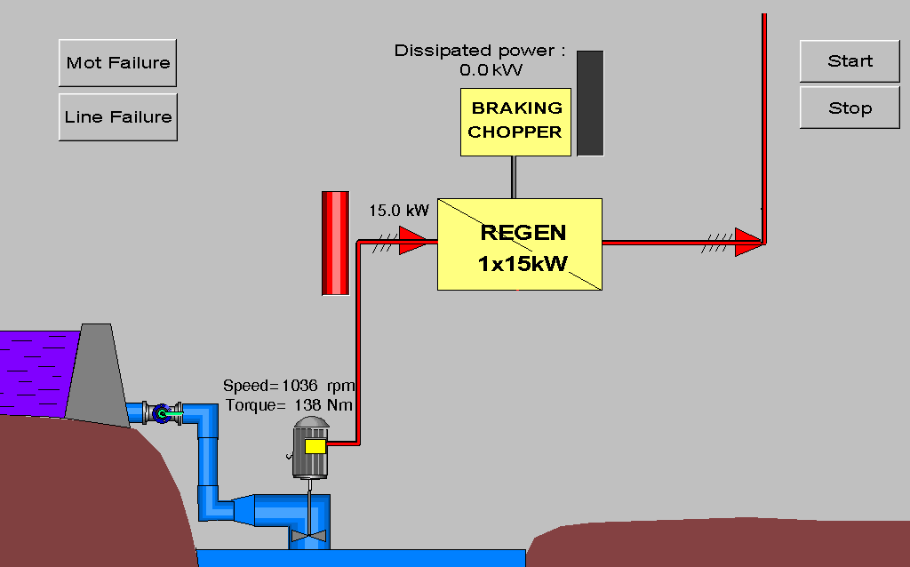Fig. 7. REGEN in grid application.

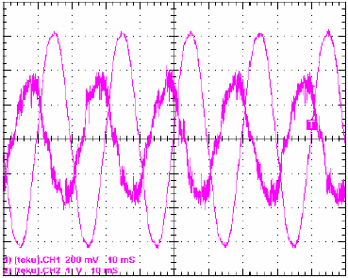
Fig. 8. Phase I and U, 10 kW, 6 poles machine,
n=50%, generating, P=50% torque, Q=50%.
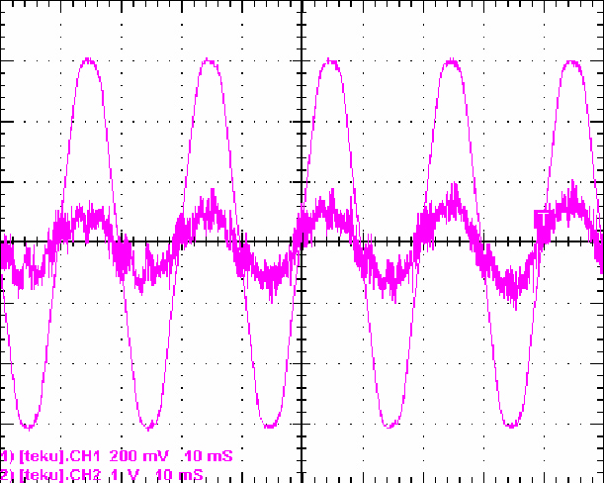Fig. 9. Phase I and U, 10 kW, 6 poles, motoring, accelerating at T=100%, n=50-->100%, Q=0%.

  - REGEN for insular networks.

A schematics for REGEN for insular networks applications is shown in Fig. 10.
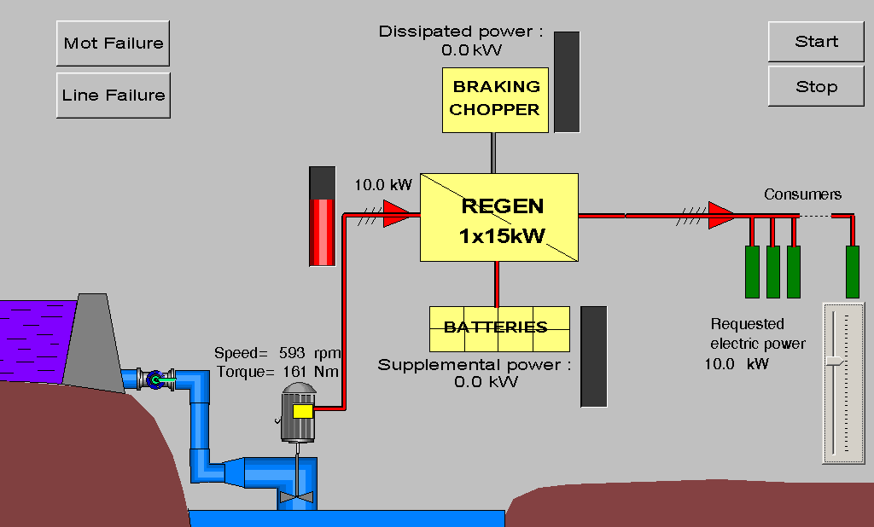Fig. 10. REGEN in insular network application.
In this configuration (see also Fig. 12), based on a proprietary new application design, REGEN uses the benefits of 2 (two) back-to-back standard 2Q frequency converters based on modern IGBT’s, available today also for PM synchronous generators.
In insular network applications the generator (turbine) will be driven with variable speed, thus allowing the system to adapt always to the output power needed by the consumers. Consequently, REGEN will manage the water resource in the above dam so that the water consumption will be minimised according to the local power needs.
Fig. 11. REGEN internal main control loop.

This speed control is implemented through a PI controller built-in the U1 converter, having as reference a prescribed value of the common DC bus voltage (580 Vdc). The turbine will be speed-manoevered so that a match between the turbine hydraulic power and the power consumed by the insular network will be achieved. The DC bus voltage will normally glide between 550 Vdc (main battery voltage) and 620 Vdc (braking chopper opens). If abrupt load variations are recorded, the DC bus voltage will momentarily touch the upper (full load loss) or lower (full load connection) margins of this interval (see fig. 13-14).
When the insular grid is working at no-load conditions (night time), the turbine speed will remain at a very low speed (8-10 Hz), covering the no-load losses of the generator, REGEN and insular distribution grid. When the consumers will plug in, the required power will increase, and the REGEN will also increase the turbine speed, in order to equalise the generated power with the required power to the grid. When the consumers switch off, the turbine speed will decrease, so that the generated power will reach the desired level. Thus, by varying the speed, REGEN will automatically cover a output power request within the 0-Pn range.
Depending on the turbine, the speed on which the turbine provides maximum power Pmax is not always corresponding to the equivalent of 50 Hz. For a stable regime, Pn has to be chosen on the rising ramp of the P=f(n) curve, while the achieved variations will be P=0-Pmax, n=0-Nmax (Fig. 5).

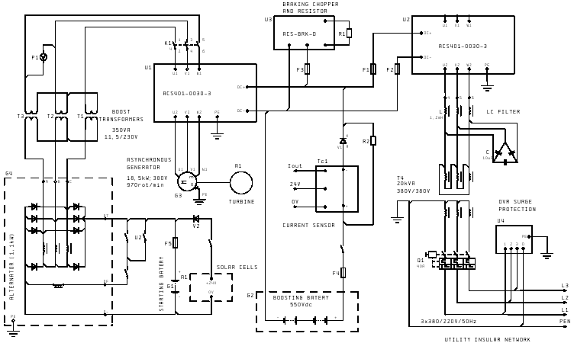
Fig. 12. Basic electric layout of REGEN 1x15 kW, for insular network supply.
Fig. 13. A.B.C.D. Dynamic behaviour of REGEN 1x15 kW at resistive load step (A - 1/3xPn; B - 2/3xPn; C - Pn;) and D - DOL starting of a 4 kW motor, no-load + 1/3xPn.
Fig. 14. A.B. Dynamic behaviour of REGEN 1x15 kW at DOL starting of motor DOL starting
(A - 4 kW motor start, B - 5.5 kW motor start).

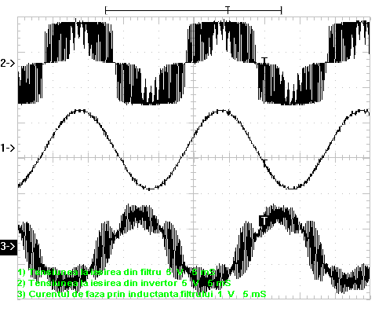Fig. 15. 1 - voltage at LC filter (output); 2 - voltage at output of U2 inverter; 3 - current in L filter component

Due to hydraulic considerations, as well as the turbine+generator mass inertia, stable load regimes are settled within 15-25 sec. As an example, if the system is loaded instantly from no-load to Pn, the final stable speed of the generator will be reached in max. 25 sec.
During this transitory regime, the output frequency will be kept perfectly still (50 Hz), while the output voltage will slightly decrease within 350-400 Vac interval, until the turbine speed will follow-up the power trend. The same time constant goes for power going down from Pn to zero. During this regime, both the voltage and frequency will be kept perfectly still (400 Vac, 50 Hz).
Fig. 15 shows the network voltage (after filtering) and at the output of the converter U2 (before filtering). Transients regimes for step-up with resistive and / or an induction motor loads are represented in Fig. 13 and 13, also showing smooth and reliable speed control of the turbine.
REGEN equipment also includes all the required components to make these transitory regimes transparent for the consumers, thus insuring 100% stable supply within 0-Pn load range.

    - REGEN for insular networks - construction details.
Referring to Fig. 12, REGEN for insular networks is composed of the following main sub-assemblies:
- The switch and control cabinet (see Fig. 15);
- Starting battery of primary cells, G1 (2 x 12V/120Ah);
- Solar battery assembly, 150 W, A1;
- Boosting / balancing battery (550V/7Ah), G2;
- Excess power dissipation module (braking chopper U3, with breaking resistor, R1);
- Output three-phase LC filter;
- Output isolating three-phase power transformer.
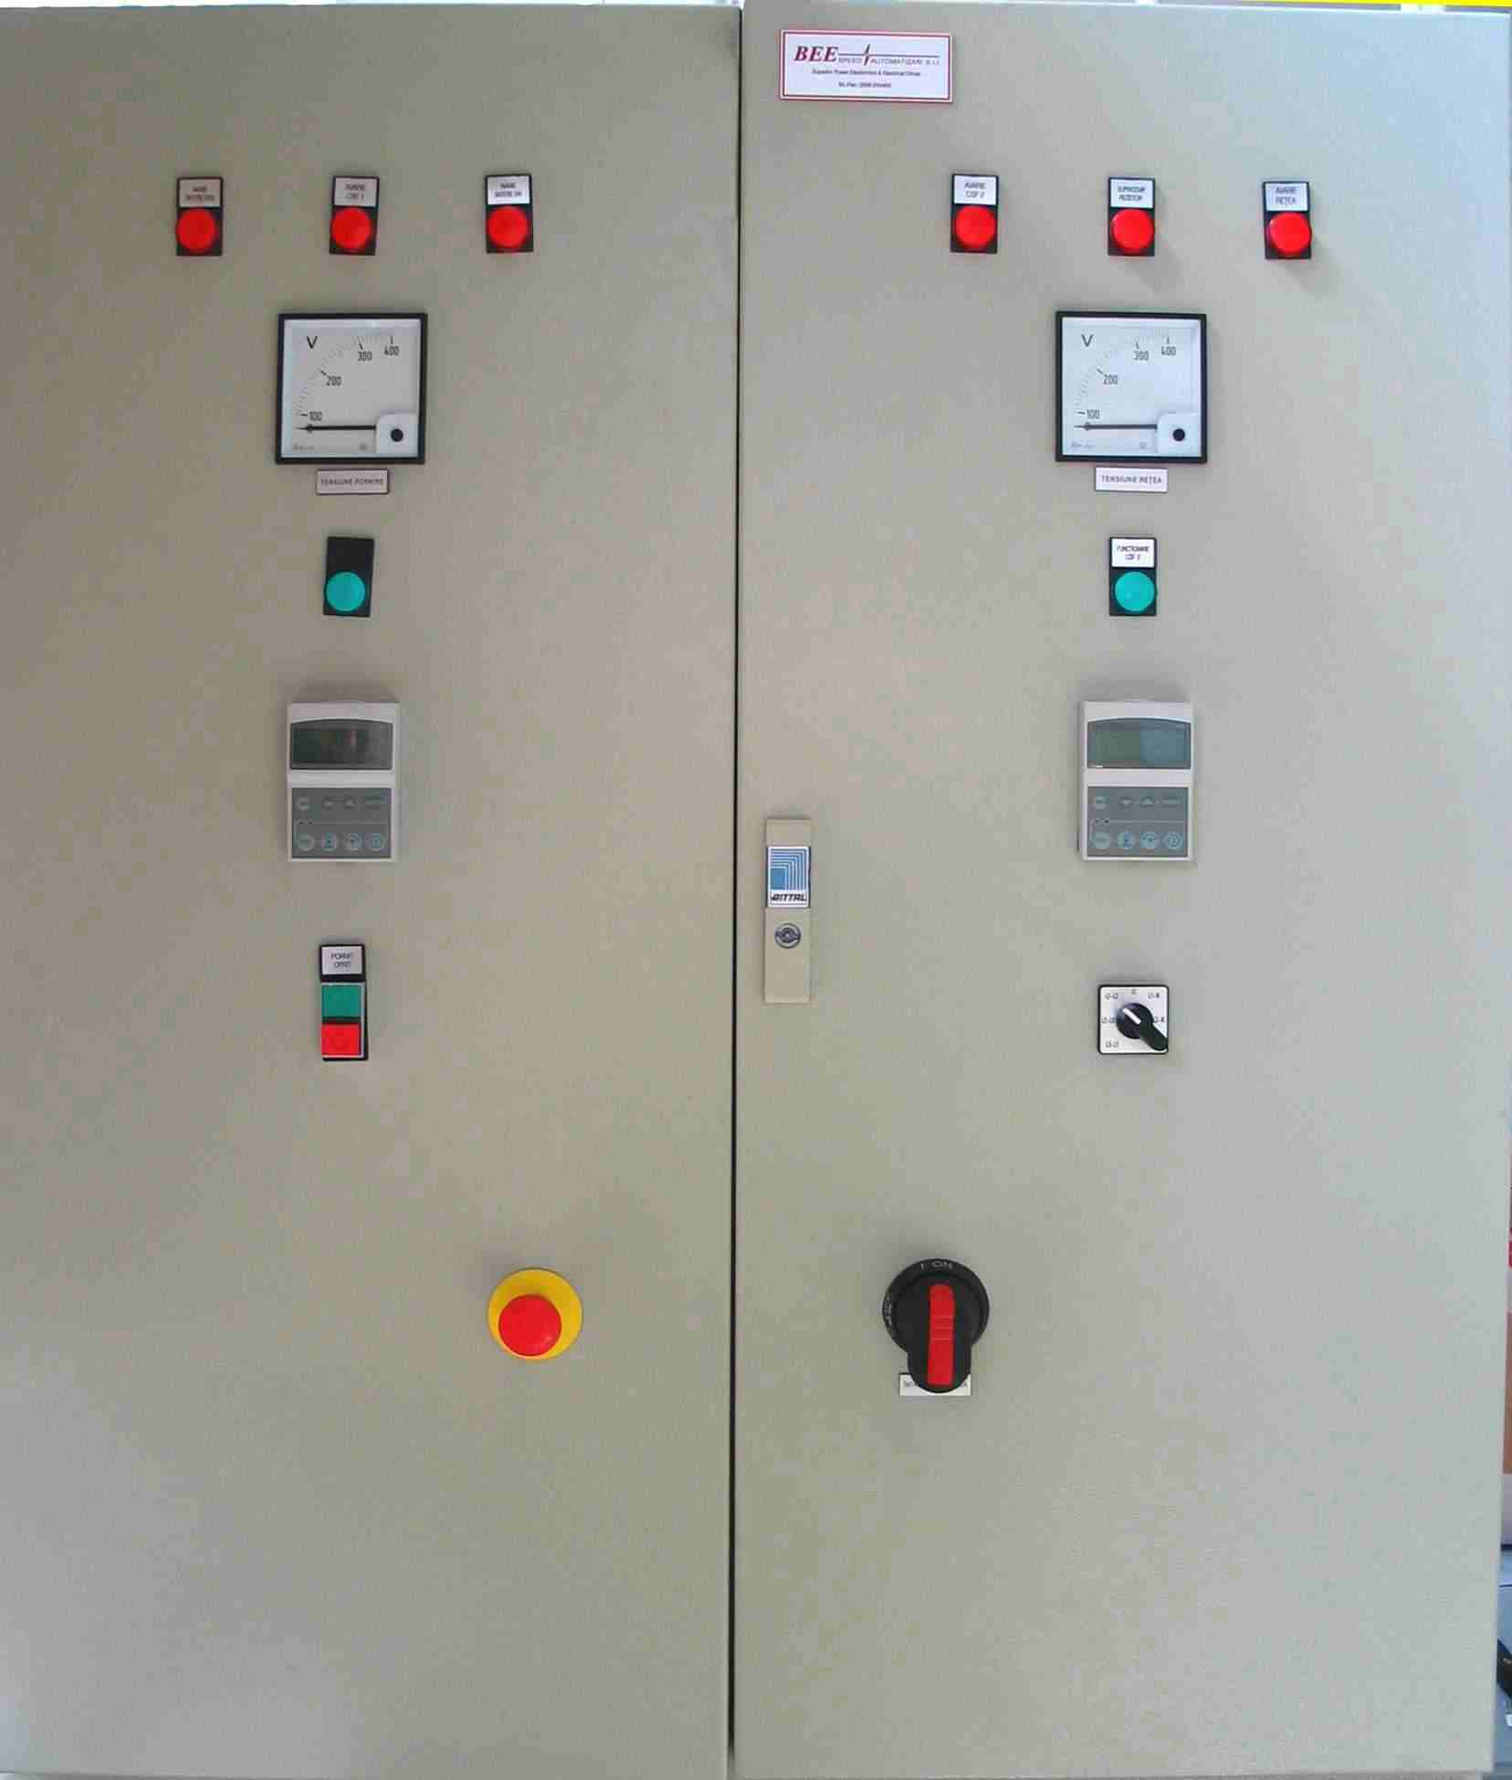
Fig. 16. REGEN 1x15 kW for insular grid.
REGEN 1x15 kW provides also the following features:
- the automation control of the inlet main valve and the guide vane (wicket gate) - if any, in order to insure safe and smooth START/STOP;
- all electric protections for the insular grid.
In order to ensure the optimal charging level of the starting battery, two systems are used: the solar battery assembly, and a vehicle alternator (24Vdc) axially coupled with the turbine shaft by a speed multiplier.
REGEN is able to feed an insular network consisting of various inductive/capacitive, 1&3 phase loads, industrial or home appliances.
The equipment supports DOL starting of induction motors in the following conditions:
(a) without REGEN output voltage shut-down, several motors can be started having the total power P_{mtot} [kW], given by the relationship:
$P_{\text{mtot}}≃\frac{I_{U2\text{hd}}−I_{U2}}{\text{15}}$ (1)
where I_{U2hd} [A] represents the rated heavy-duty current of the converter U2, and I_{U2} [A] is the actual load current of the converter U2 (displayed on the control panel).
- with temporary shut-down of the REGEN output voltage for maximum 2 sec. followed by the voltage restoring (U/f=ct.), several motors can be started having the total power P_{mtot} [kW], given by the relationship:
$P_{\text{mtot}}≃P_{n}−P_{U2}$ (2)
where: P_{n}=15 [kW], and P_{U2} [kW] is the actual load power of the converter U2 (displayed on the control panel).
When connecting an active power load, the REGEN output voltage decreases to a minimum value of 345V (i.e. U_{n}-10 %), for a variable time Δt [sec], given by the approximate relationship, coming from experimental results (see Fig. 13.c):
$Δt≃\text{25}⋅\frac{P_{\text{con}}}{P_{n}}$ (3)
where P_{con} [kW] is the active power of the load to be connected, and P_{n}=15 [kW]. After the time interval Δt, the voltage is restored at its rated value.
When disconnect/switch-off of an active load occurs, the REGEN output voltage remains at the rated value U_{n}.
The frequency of REGEN output voltage is kept at its rated value (i.e. 50 Hz), either when switch-on, or switch-off the loads in the insular network, except the situation presented in the above condition (b).
In the event of a malfunction, the equipment shuts-down automatically, and the fault type is stored in the memory of the mini-programmable logic module.
REGEN also includes hardware equipment to insure its protection against any kind of grid or generator failure, as follows:
- overcurrent, for all the circuits;
- overvoltage surges, the utility insular network;
- overtemperature, the braking resistor.

3.3. REGEN for grid and insular networks
REGEN can be adapted to supply both national grid and local insular network, Fig. 16, thus bringing a number of supplemental advantages:
- 100% up-time for the local insular grid (when the national grid fails, the local consumers will be kept alive, with automatic re-synchronisation at grid resurrection);
- pump storage capabilities (pumping excess water - if available - back in the dam during the night time, when the energy is cheaper from the national grid);
- energy management capabilities (maximising the injected power when during the hours when the energy tariff is higher, etc.).
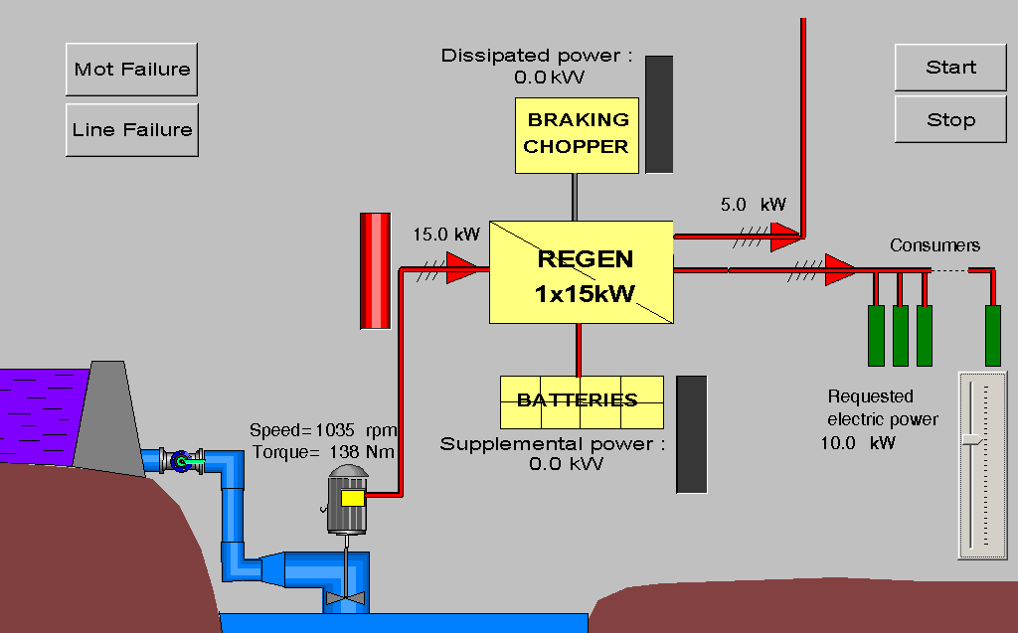Fig. 17. REGEN for grid and insular network supply.

4. Applicability and conclusions.
REGEN can run, with variable speed, synchronous (with classic excitation or permanent magnets) or asynchronous (squirrel cage or wound rotor) machines, driven by:
- a). reaction type turbines (Kaplan - propeller, bulb, S-shape, siphon; Francis; centrifugal pumps as turbines - PAT), on which the flow variation is induced directly by the speed variation, without the need for guide-vanes or orientable rotor blades;
- b). impulse type turbines (Pelton, Banki, Turgo), on which the flow variation is not related to speed variation (guide vanes - or equivalent - still required).
The best results can be obtained in combination with reaction type turbines (a), i.e.:
- avoid permanent use of a wicket guide vane in order to adapt water flow to the power consumption;
- avoid the hydraulic & mechanical parts used in order to modify the blade attack angle, thus simplifying the turbine construction (reduced shaft diameter, no oil needed, etc.);
- possibility to easily find the speed which corresponds to the optimum efficiency (usually different from the rated generator speed);
- controlled and smooth start-up and shut-down for the turbine, without any overspeed (not even when the supplied grid fails);
- water and energy management possibilities, depending on the local conditions;
- pump-storage capabilities (night pumping if the national grid is available);
- autonomous functionality (no personnel required), plug&play type, self-protected, self-ventilated compact and fully programmable according to the local specifics;
- possibility to incorporate a digital communication line (modem on GPRS, regular telephone lines, radio, etc.) which allows on-line monitoring & remote control from distance;
In combination with impulse type turbines (b), REGEN is especially useful in feeding insular networks, with the following supplemental advantages:
- avoid using the ballast load resistors;
- permanent and flexible adaptation of turbine power (speed) to the power requested by the local consumers;
- rational water consumption (according to the power needs).

5. Acknowledgements.
The authors wish to address their gratitude to Mr. Peter Ruyter, Kraft&Cargo AB for the possibility to perform REGEN live testing on Kaplan turbines on Kraft&Cargo hydraulic testing stand in Sweden.

6. References.
- L.H. Hansen, P.H. Madsen, F. Blaabjerg, H.C. Christensen, U. Lindhard, K. Eskildsen, “Generators and Power Electronics Technology for Wind Turbines” – Record of EECON-2001, pag 2000-2005.
- P. Bauer, S.W.H. de Haan, M.R.Dubois, “Windenergy and Offshore Windparks: State of the Art and Trends” – Record of EPE-PEMEC-2002 pag. 1-15.
- A.S. Neris, N.A. Vovos, G.B. Giannakopoulos, A Variable Speed Wind Energy Conversion Scheme for Connection to Weak AC Systems” – IEEE Transactions of EC, Vol.14, No.1, March 1999, pag 122-127.
- L.M. Popa, I. Boldea, F. Blaabjerg, “Simulation of Wind Generator Systems for the Power Grid” – Record of OPTIM, 2002, Poiana Brasov, Romania.
- ∗∗∗ Layman's Guidebook on how to develop a Small Hydro Site, European Small Hydro Association and Commission of the European Communities, DG XVII, Brussels, 1994.
- J. Bard, “Status Report on Variable Speed Operation in Small Hydropower“, Institut für Solare Energieversorgungstechnik (ISET) e.V., Kassel, December 2000.
- J. Bard, “Innovative Betriebskonzepte. Erstes Anwenderforum Kleinwasserkraftwerke”, Otti Technologiekolleg, Universität Kassel, Oktober 1998.
- D. Roberts, I. Bard, “Variable speed operation of axial flow turbines”. In: Hydropower and Dams, 2/98, Shanghai.
- J. Schirm, A. Schmitt, “Turbines with Variable Speed Control for the Hydropower Plant “Beim Preussischen” of the Stadtwerke Rottenburg”. In: Wasserwirtschaft, 82. Jahrgang, 5 / 1992, S. 246-249.
- Romanian Patent RO-112219/B1.

